**Hierarchical Clustering**

Instructions:

Please share your answers filled inline in the word document. Submit Python code and R code files wherever applicable.

Please ensure you update all the details:

**Name: _________________________**

**Batch Id: _______________________**

**Topic: Hierarchical Clustering**

**1. Business Problem**

* 1. **Objective**
  2. **Constraints (if any)**

**2. Work on each feature of the dataset to create a data dictionary as displayed in the below image:**

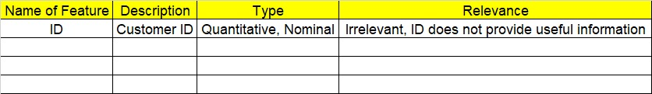

**Using R and Python codes perform:**

**3. Data Pre-processing**

**2.1 Data Cleaning, Feature Engineering, etc.**

**4. Exploratory Data Analysis (EDA):**

**4.1. Summary**

**4.2. Univariate analysis**

**4.3. Bivariate analysis**

**5. Model Building**

**5.1 Build the model on the scaled data (try multiple options)**

**5.2 Perform the hierarchical clustering, visualize the clusters using dendrogram**

**5.3 Validate the clusters (try with different no. of clusters) – label the clusters and derive insights (compare the results from multiple approaches)**

**6. Share the benefits/impact of the solution - how or in what way the business (client) gets benefit from the solution provided.**

**Note:**

The assignment should be submitted in the following format:

* R code
* Python code
* Code Modularization should be maintained
* Documentation of the modules (elaborating on steps mentioned above)

**Standard Grading Guideline :**

**Grade A: All assignments submitted correctly on Time (with all mentioned content like: python code, r code, documentation)**

**Grade B: All assignments submitted but post the due date. Or Partial assignments are submitted.**

**Grade C and Grade D: Partial assignments submitted with incorrect answers, or worked on only R or Python or not all the content is submitted.**

**Grade F: Partial assignments submitted with incorrect answers and not all the content is submitted.**

**Problem Statement:**

1. Perform clustering for the airlines data to obtain optimum number of clusters. Draw the inferences from the clusters obtained. Refer to EastWestAirlines.xlsx dataset.

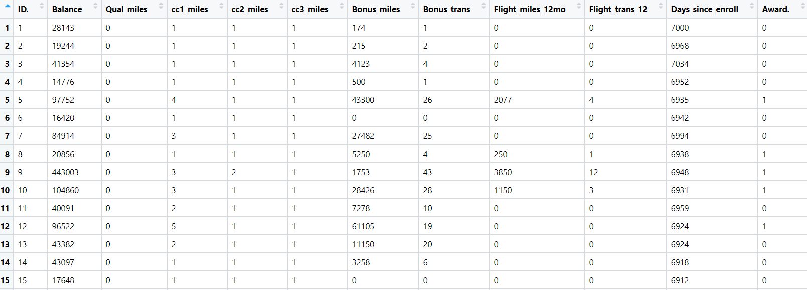

1. Perform clustering for the crime data and identify the number of clusters formed and draw inferences. Refer to crime_data.csv dataset.

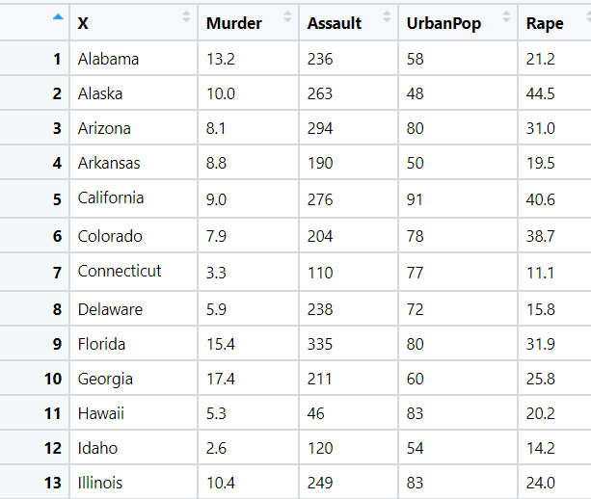

1. Perform clustering analysis on the telecom data set. The data is a mixture of both categorical and numerical data. It consists the number of customers who churn. Derive insights and get possible information on factors that may affect the churn decision. Refer to Telco_customer_churn.xlsx dataset.

Hint:

* Perform EDA and remove unwanted columns.
* Use Gower dissimilarity matrix, In R use daisy() function.



1. Perform clustering on mixed data convert the categorical variables to numeric by using dummies or Label Encoding and perform normalization techniques. The data set consists details of customers related to auto insurance. Refer to Autoinsurance.csv dataset.

